Project CSC 211

Spring 2021

Giuseppe Marcoccio

Write a C++ program using C++ Classes, Structure, Arrays, Vectors,

Functions, Pointers, Advance File IO and C++ STL to do the following:

Display a Main Menu below with Menu options and your company heading.

Also, you name must be in the program

A. Read from a file the Items bought Items ID, Name, Quantity and Price

B. Calculate order the total for each item, Add them up for a sub-total

and calculate the tax (NYC is 8.875%) and the Grand Total

C. Write to an out file and Screen with the sorted output of 5 items,

quantity, price and total for each item, sub-total, tax and grand

total. (Just like a receipt you get from the store)

D. Print out current inventory

E. Find and Display items ordered using Order #

F. New order

G. Add Inventory

H. Exit

Please use the following data to create a text file for Order 1.

(Could have multiple orders or give option for new order)

Itemed Name Qty

101 Coffee-Mug 4

102 T-Shirt 5

103 Keychain 8

104 Cardholder 7

105 Phone-case 6

Default Constructor name: Crafting (Use this to start your inventory)

Itemed Stonehands Retail Price Each

101 100 4.50

102 150 8.75

103 200 1.15

104 80 7.75

105 155 6.50

You must upload the .h, .cop files, outdate file, picture of working program -

jpg, pang, bmp (upload all individual files same time, do not zip files) Your

name must be in the code and remember comments.

Plan your program before you begin. Your coding must be original. DO NOT COPY CODE.

Output:

Program Initialize

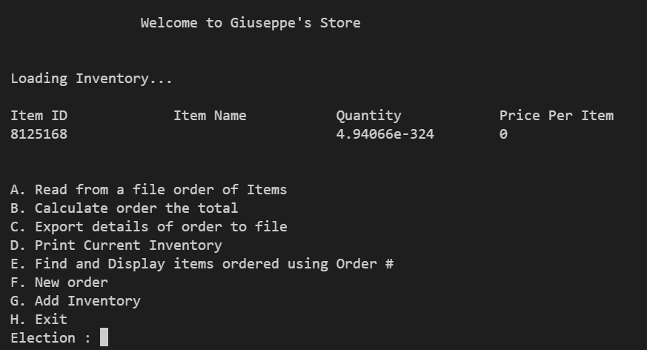

Program - Input = ‘A’ as selection.

* Input = ‘Order.txt’ as order from user.
* Input = ‘1’ as key number for order.

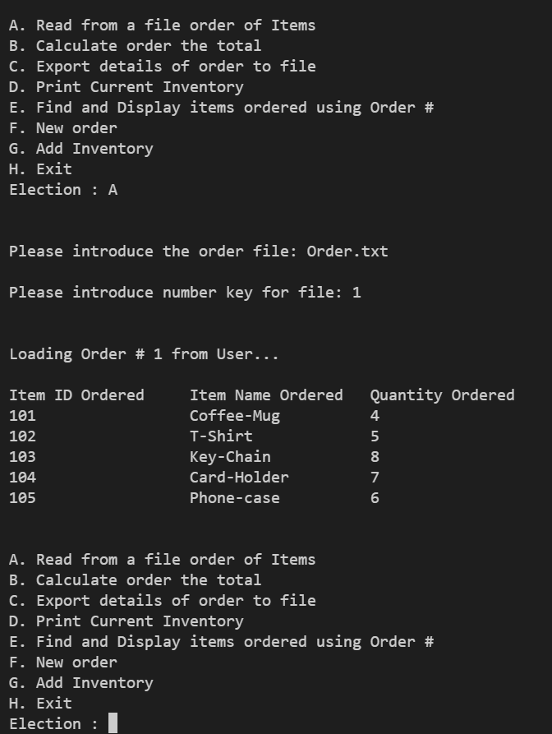

Program - Input = ‘B’ to calculate order

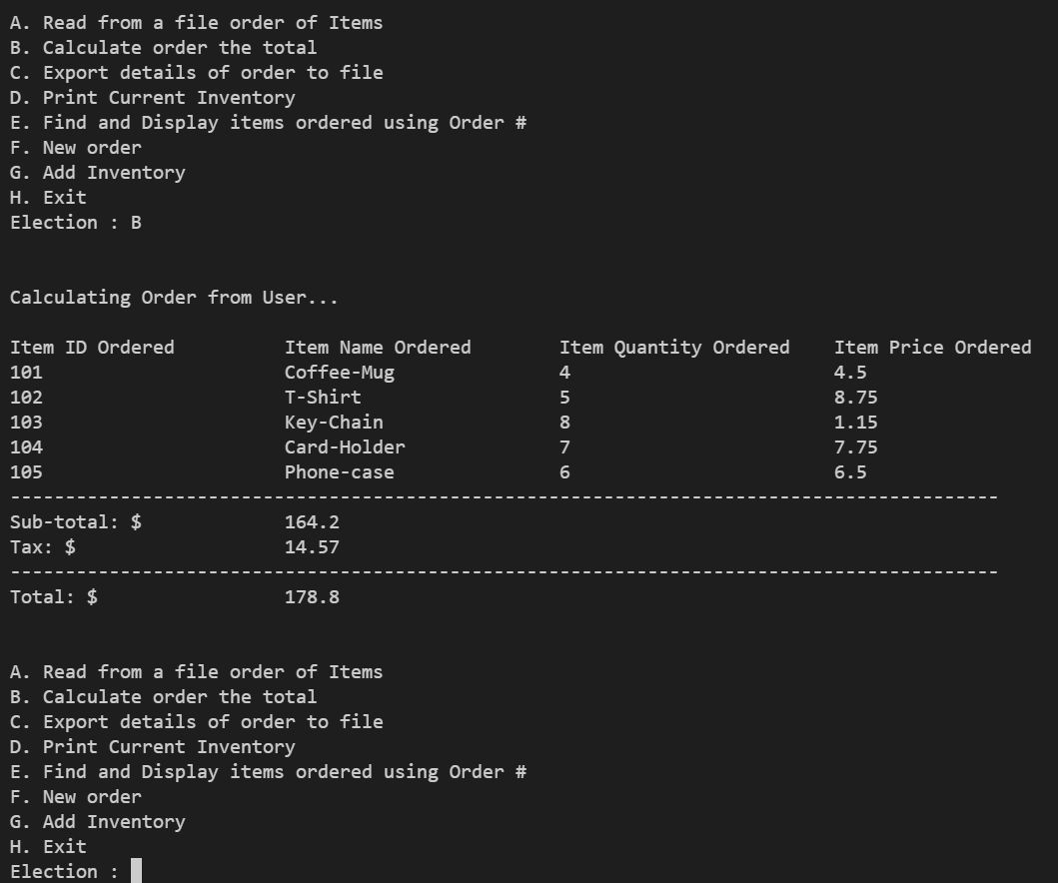

Program Input = ‘C’ to Export details of order to receipt file.

Input = Key Number of files.

Input = Name of file to export.

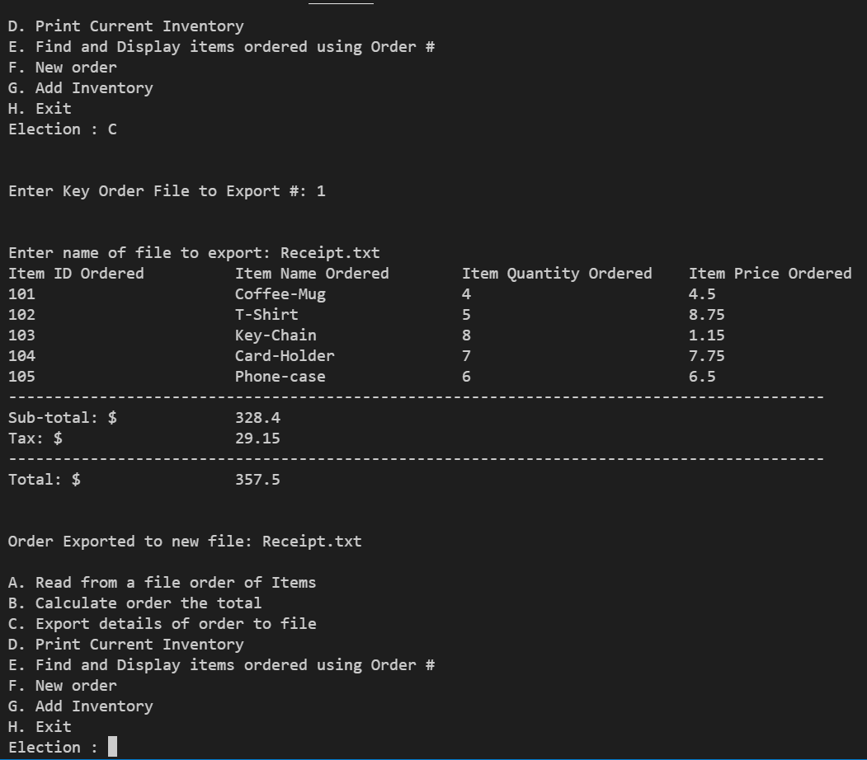

Program Input = ‘D’ to print current Inventory

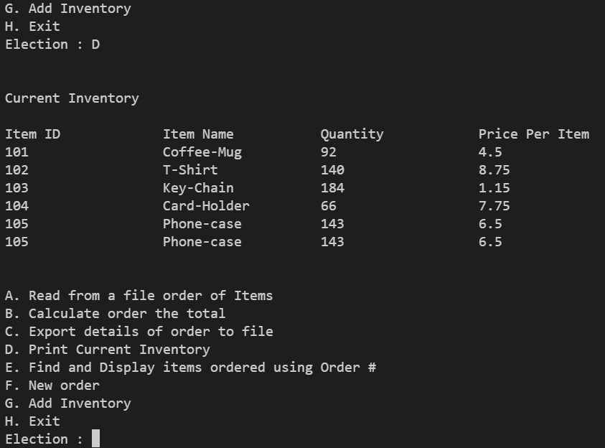

Program Input = ‘E’ to find and Display items ordered using the key number

Input = key number of files to display

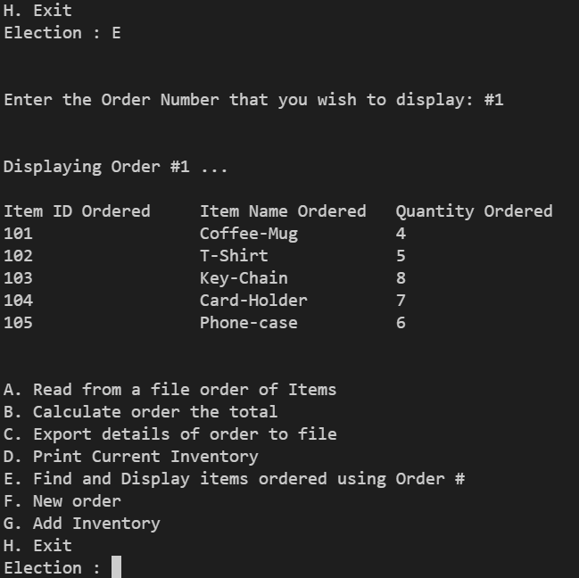

Program Input = ‘F’ to add a new order to program

* Input = ‘OrderA.txt’ as order from user
* Input = ‘2’ as key number for order

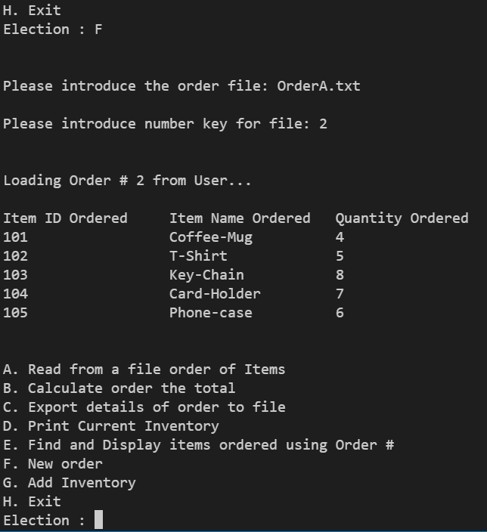

Program Input = ‘G’ to add new inventory

Input = Name of file with new Inventory

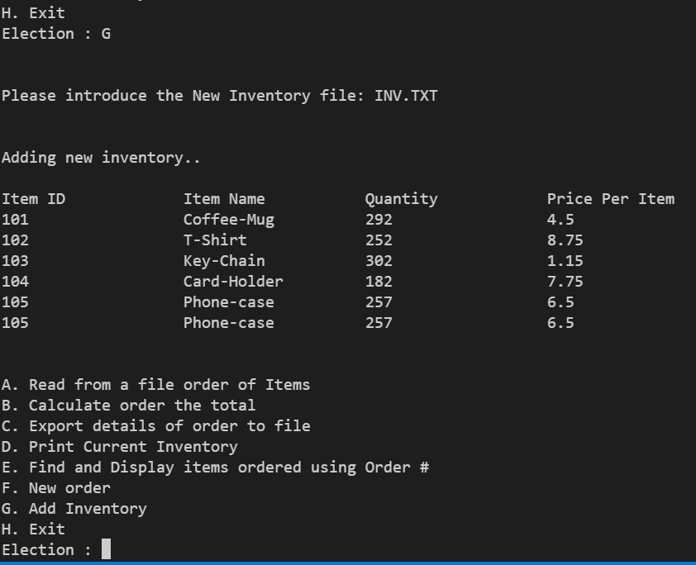

Program Input = ‘H’ Terminate the program

